

**Arcserve**

**Plugin Configuration Guide**

Contents

Supported Collection Types 2

Data Sources 2

Requirements 2

Arcserve SQL Database Connection 2

Arcserve Log Files 2

*Permissions* 3

Setup 4

Server Properties 4

Field Definitions 4

Technical Support 6

# Supported Collection Types

The plugin currently supports the following collection types from Arcserve servers:

|  |  |  |
| --- | --- | --- |
| **Collection Type** | **Supported** | **Description** |
| Backup | ✓ | Collects transactional details about backup, duplication and restore jobs. Example metrics include, start times, durations, bytes, files, errors etc. |
| Storage |  | Collects point-in-time inventory information. Example metrics include, total recoverable gigabytes (occupancy), media volume count, media volume status, etc. |
| Policy |  | Collects and stores information on policy attributes, schedules, storage units, storage groups, storage lifecycle policies and clients. |

# Data Sources

The Plugin relies on at least one the following Arcserve data sources:

* Arcserve SQL Database Connection
* Arcserve log files (Brightstore.log and Job.log)

# Requirements

This section lists requirements that must be met prior to collecting data with the Bocada plugin for Arcserve. The Bocada Data Collection Server must be able to connect to the Arcserve server on the port(s) that the Arcserve software responds to. By default, the TCP port for an Arcserve server is 1433.

### Arcserve SQL Database Connection

The first attempt by the plugin to collect data is directly from the Arcserve database. If the database connection fails or is not available, collection will fall back to the Arcserve log files.

The Bocada collection engine relies on the Bocada Data Collection Service. In some environments running the service under the *Local System* account may not grant the plugin sufficient permissions to collect data from Arcserve servers. In this case, change the “Log On” for the Data Collection Service to use a named account.

### Arcserve Log Files

#### ***Location***

The plugin needs the location of the log files on the Arcserve server in order to collect data. If the default log share is present on the Arcserve server, the preferred method is to direct the plugin to search for the log files. On non-standard installations of Arcserve, the preferred method is to provide the plugin with the server’s installation path.

#### **Permissions**

In order to read the Arcserve log files, the plugin requires a login with read access to the log file location.

If the search for the default log share fails, the plugin determines the Arcserve log file location by reading the Windows Registry.

In order to read the Windows Registry, the plugin requires Administrator access. This level of access is not required if the default log share is present, or the plugin is provided the path to the log files.

# Setup

### Server Properties

Backup Server Properties determine how the plugin will interface with the Arcserve server and are managed through the Backup Servers view.

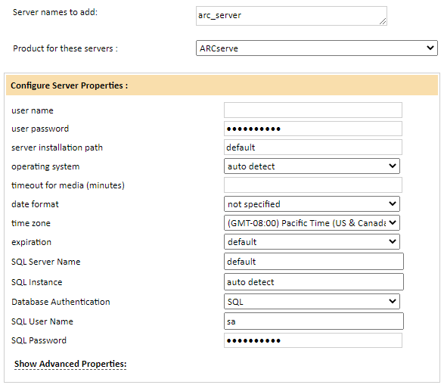

### Field Definitions

#### User Name & Password

Enter the username and password used to access the Arcserve backup server.

#### Server Installation Path

Leave as *default* or enter the installation path of the Arcserve software on your backup server

#### Operating System

Select *auto detect* for the operating system.

#### Timeout for Media

Disregard this field unless instructed by Bocada Support to enter a setting.

#### Date Format

Select the date format used by your Arcserve server installation.

#### Time Zone

Select the time zone where Arcserve server resides. This setting ensures times are displayed consistently in environments that span multiple time zones.

#### Expiration

Specify how the plug-in will determine the media expiration for jobs. Media expiration information is not available from Arcserve. You can use this setting to record an expected media expiration for backup jobs. Choose default to set the media expiration to the same value as the job date time. Otherwise choose an expiration period that matches the majority of the jobs performed by the server.

#### SQL Server Credentials

Enter the Arcserve SQL Server Name and Instance where applicable. Choose an authentication method and enter SQL credentials with access to the Arcserve database.

# 

# Technical Support

For technical support or a copy of our standard support agreement, please contact us.

**E-mail:** [support@bocada.com](mailto:support@bocada.com)

**Support Portal:** <http://www.bocada.com/support/>

**Phone:** +1-425-898-2400